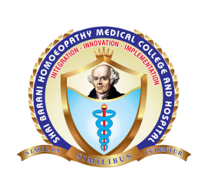
SHRI BARANI HOMOEOPATHY MEDICAL COLLEGE AND HOSPITAL
PILLIKALMEDU, KOKKARAYANPETTAI (PO), TIRUCHENGODE (TK), NAMAKKAL (DT) -638007
ANTI-RAGGING COMMITTEE / ANTI-SEXUAL HARASSMENT COMMITTEE

Name | Designation | Contact Number | Mail ID
Dr. R.N.Arul | Chairman, Anti-Ragging Committee, Principal | 9994466562 | arulrn2010@yahoo.com  shribaranihmch@gmail.com
Dr. K.Punithavathi | Secretary / Managemnet Committee | 9894264333 | shribaranihmch@gmail.com
Er.R.Varun | Executive Officer / Management Committee | 8012504999 | shribaranihmch@gmail.com
Dr.C.P.Sowbharnika | Director / Management Committee | 7708571133 | shribaranihmch@gmail.com
Dr.V.Karthikeyan | Vice-Principal / Member | 9994286222 | drkarthi222@gmail.com
Mrs.S.Vimala IPS | Superintendent of Police |  | shribaranihmch@gmail.com
Dr.P.Ramachandran | Parents committee | 9025576445, 9444045052
Ms. Kanimozhi | Students Committee
Mr.Pradeep | Students Committee | 9751875321
Mr. Nagulan | Students Committee | 9342149849

